Saffron Royalty: Super Negin and Kashmiri Mongra – The Golden Threads of Purity from The Export Express
Meta Description: Discover the world's finest saffron — Afghan Super Negin and Kashmiri Mongra. Learn their origins, specs, benefits, and how The Export Express brings this golden luxury to global markets.

🌸 Introduction: The World’s Most Precious Spice
Known as “Red Gold”, saffron (Crocus sativus L.) has enchanted civilizations for over 3,000 years. Its vivid color, distinct aroma, and therapeutic properties make it one of the world’s most valuable and sought-after spices.
At The Export Express, we proudly offer two of the most elite saffron varieties — Afghan Super Negin Saffron and Kashmiri Mongra Saffron — both renowned for purity, coloring strength, and luxurious aroma. Cultivated under ideal climates and processed by skilled artisans, our saffron defines excellence for culinary, medicinal, and wellness applications.

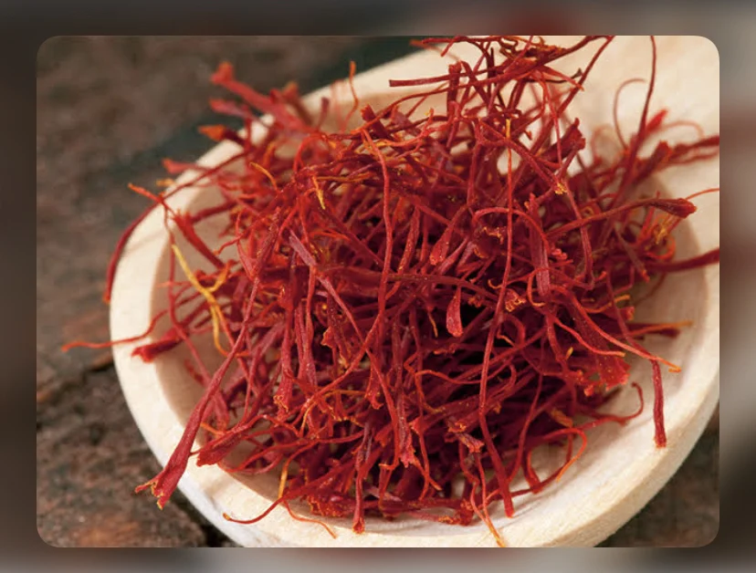
Caption: The golden-red threads of Super Negin and Mongra Saffron — nature’s symbol of luxury and wellness.

🏅 The Two Pinnacles of Saffron Quality

1. Super Negin Saffron (Afghanistan – Premium Grade)
Origin: Afghanistan
Botanical Name: Crocus sativus L.
Grade: Super Negin
Shelf Life: 18–24 months
Form: Dried stigmas (threads only)
Availability: In Stock
Super Negin saffron represents the highest standard of saffron globally, prized for its deep red color, long uniform strands, and extraordinary aroma. Each stigma is handpicked, symmetrically cut, and gently dried to preserve its volatile compounds — safranal, picrocrocin, and crocin — responsible for flavor, aroma, and color.

🔬 Technical Specifications
Parameter | Value
Coloring Strength (Crocin) | 240–290 (ISO 3632 Grade I)
Flavor (Picrocrocin) | 85–95
Aroma (Safranal) | 35–45
Moisture Content | ≤12%
Ash Content | ≤6%
Form | Long, symmetrically cut red stigmas
Appearance | Uniform, flat, thick, and deep crimson
Odor | Strong, pleasant saffron aroma
Taste | Bitter-honeyed
Purity | 100% natural, ISO & FSSAI certified
Production Insight:
Harvesting Super Negin requires exceptional skill and precision. Each flower produces just three stigmas, hand-separated and sun-dried at controlled temperatures to retain color and aroma. This meticulous craftsmanship makes Super Negin rare, potent, and costly.

🌿 Uses & Applications of Super Negin Saffron
- Culinary:
Adds royal flavor and color to biryani, Persian rice, risotto, kheer, paella, ice creams, and confectioneries.
- Beverages:
Used in saffron tea, milk infusions, and luxury herbal drinks.
- Medicinal & Nutraceutical:
Supports mood balance, heart health, and antioxidant activity; used in premium supplements and extracts.
- Cosmetic & Aromatherapy:
Incorporated into skincare and perfumes for radiance and rejuvenation.

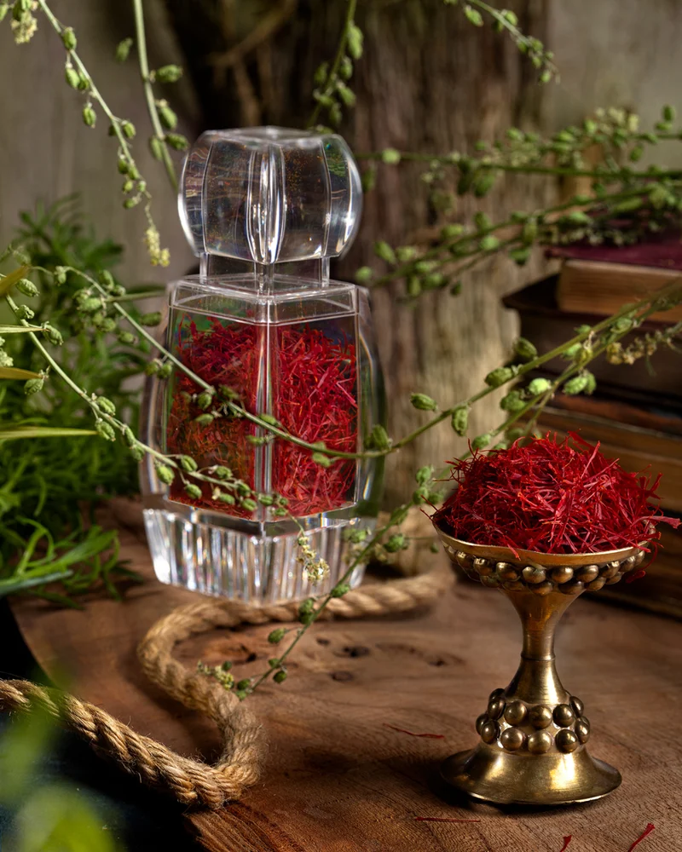
Caption: Super Negin Saffron – the world’s most refined saffron, valued for its potency, purity, and vibrant hue.

2. Kashmiri Mongra Saffron (India – Heritage Grade)
Origin: Pampore, Kashmir, India (GI Certified Region)
Botanical Name: Crocus sativus L.
Grade: Mongra / Mogra
Shelf Life: 18 Months
Packaging Size: 1 gm | Packaging Type: Plastic pouch / Glass jar
Certifications: ISO, FSSAI, Organic Certified
Kashmiri Mongra Saffron is India’s pride — known as the darkest and most aromatic saffron in the world. Cultivated in the saffron town of Pampore, the region’s cold winters and rich soil produce thicker, darker stigmas that deliver exceptional flavor, color, and fragrance.

🔬 Technical Specifications
Parameter | Value
Coloring Strength (Crocin) | ≥250
Flavor (Picrocrocin) | 90–95
Aroma (Safranal) | 35–45
Stigma Length | ~2.5 cm
Color | Deep crimson-red
Moisture Content | <12%
Purity | 100% red stigmas
Botanical Name | Crocus sativus
Shelf Life | 18 months
Variety Available | Mongra, Laccha, Zarda
Why Mongra is Special:
Unlike Iranian or Spanish saffron, Mongra saffron threads are shorter, thicker, and darker — ensuring high pigment concentration and flavor depth. It is three times more powerful than other natural colorants and retains aroma even after cooking.

📦 Packaging Options by The Export Express
Product | Form | Packaging Size | Type
Super Negin Saffron | Threads | 1g, 5g, 10g | Plastic pouch / glass vial
Kashmiri Mongra Saffron | Threads | 1g, 5g, 25g | Airtight plastic pouch / tin
Bulk Export | Threads | 100g – 1kg | Vacuum-sealed pouch with nitrogen flush
All saffron is vacuum-packed in air-tight, light-resistant packaging to preserve aroma and coloring power.
Private labeling and OEM customization are available for global export clients.

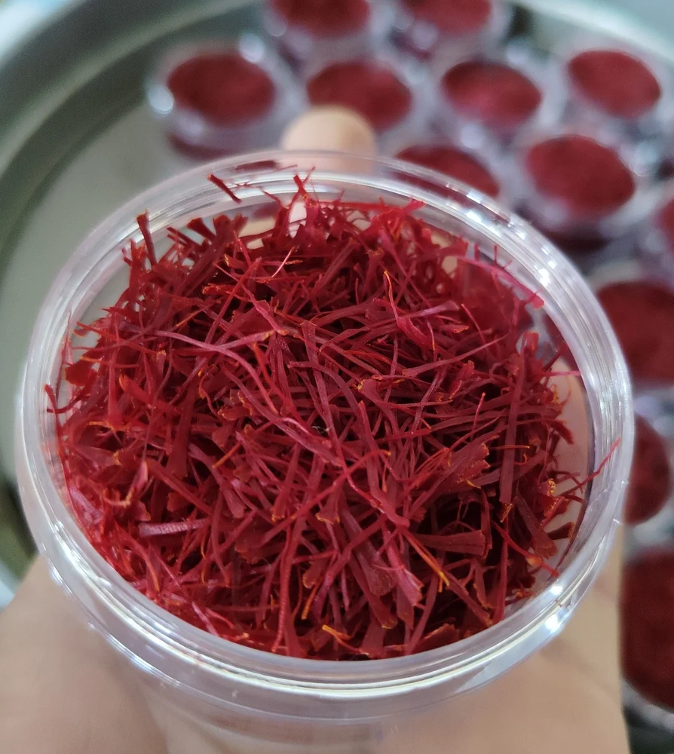
Caption: The Export Express ensures purity, traceability, and luxury packaging for every saffron strand.

💫 Culinary & Wellness Benefits
- Rich Natural Colorant: Gives vibrant golden-yellow hues to dishes.
- Mood & Stress Support: Contains safranal, known for mild antidepressant effects.
- Antioxidant Boost: Protects cells from oxidative stress and inflammation.
- Heart & Reproductive Health: Enhances circulation and vitality.
- Skin Radiance: Used in Ayurvedic and luxury skincare for glow and rejuvenation.

🧴 Certifications and Quality Assurance
- ISO 3632 Grade I (Lab-tested crocin 250–290 units)
- FSSAI & Organic Certified
- GI-tagged Kashmiri Saffron for traceability
- Hand-harvested and sun-dried
- Free from artificial colorants or additives

🔗 Suggested Internal Links
- Explore More Ayurvedic & Herbal Exports from India
- Shop Premium Saffron Exports
- Learn About Our Certifications & Sourcing
- Contact for Bulk & Private Label Orders

🌏 Conclusion: The Golden Signature of Purity and Luxury
Whether in a chef’s kitchen or a wellness supplement, saffron remains the essence of luxury and purity.
At The Export Express, we deliver the finest Super Negin and Kashmiri Mongra Saffron, each batch lab-tested, ethically sourced, and expertly packed for global export.
Bring home the brilliance of red gold — where heritage meets quality and nature meets perfection.

Keywords: Saffron exporter India, Super Negin saffron, Kashmiri Mongra saffron, Herbal export India, premium saffron for export, saffron suppliers from India.

